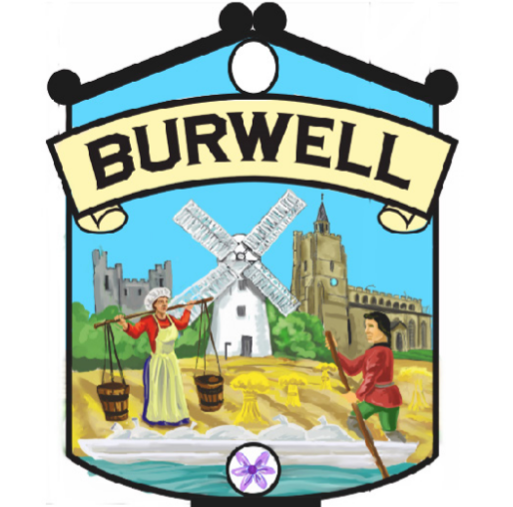
ANNUAL PARISH MEETING
TUESDAY 4th MAY 2021 at 7.30 PM
This meeting will be held virtually using Zoom and the link for the meeting is https://us02web.zoom.us/j/83835264697 Meeting ID: 838 3526 4697

(The Local Authorities and Police and Crime Panels (Coronavirus) (Flexibility of Local Authority and Police and Crime Panel Meetings) Regulations 2020.

AGENDA

- Welcome – Liz Swift, Chairman Burwell Parish Council
- Report from Finance and General Purposes Working Group
- Report from the Assets and Environment Working Group
- Report from the Community, Leisure and Sports Working Group
- Report from the Safety Working Group
- The Gardiner Memorial Hall Refurbishment
- Other Reports
- Question Time

