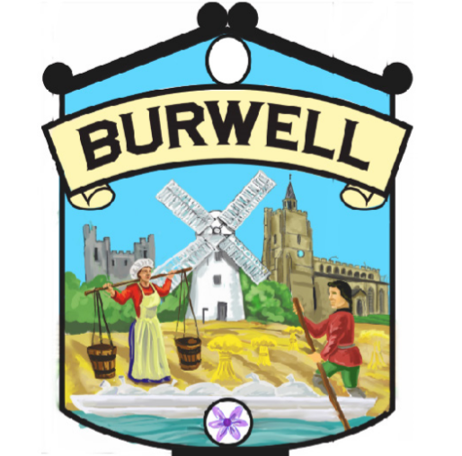
ANNUAL PARISH MEETING
TUESDAY 4th MAY 2021 at 7.30 PM
This meeting will be held virtually using Zoom and the link for the meeting is https://us02web.zoom.us/j/83835264697 Meeting ID: 838 3526 4697

(The Local Authorities and Police and Crime Panels (Coronavirus) (Flexibility of Local Authority and Police and Crime Panel Meetings) Regulations 2020.

AGENDA

- Welcome – Liz Swift, Chairman Burwell Parish Council
- Report from Assets and Environment Working Group
- Report from the Finance and General Purposes Working Group
- Report from the Community, Leisure and Sports Working Group
- Report from the Safety Working Group
- The Gardiner Memorial Hall Refurbishment
- County and District Councillor Reports
- Question Time

If you wish to raise a question during the meeting please use the Chat Facility
to the Yvonne Rix Clerk. Please give your full name. You will then be given an
opportunity to speak during the Question Time at the end of the meeting.

Thank you

