LBF Report 20.04.26

Bins:
https://www.espo.org/harribin-hooded-top-litter-bin.html | £208 | 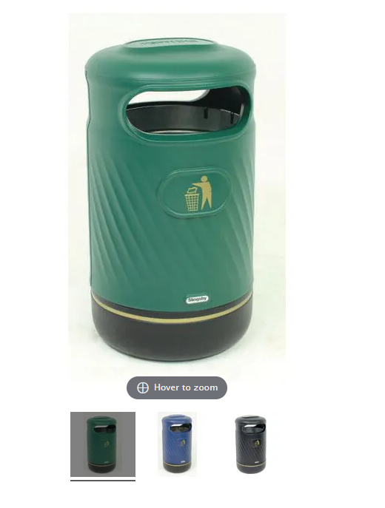
https://uk.glasdon.com/litter-bins/outdoor-litter-bins/glasdon-jubilee-tm-110-litter-bin | £431.60 | 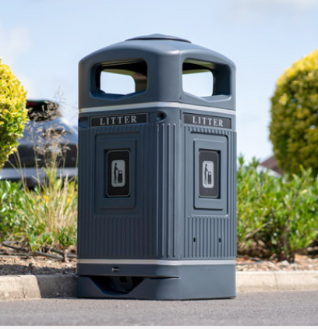
https://uk.glasdon.com/topsy-2000-tm-litter-bin | £202.92 | 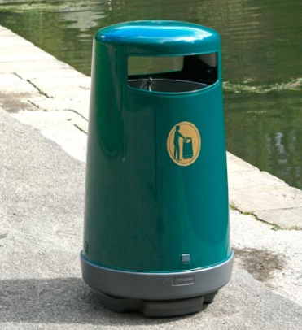
 | £162 | 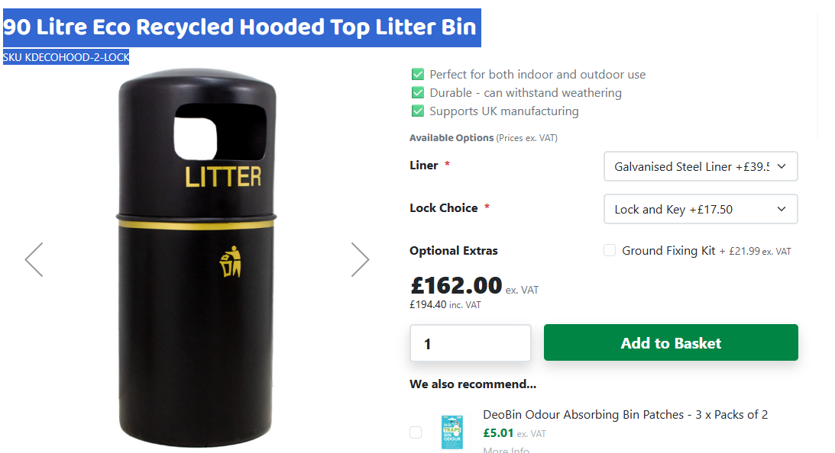
: cost: £1014.60 ext VAT each)
cost £2158.00 ext VAT each)

5 required: Jubilee Green x 2, Cemetery x 1, 1 by basketball courts, 1 x Priory meadow

Benches
Possible chatty bench

Mandeville:
£124.21 Folding Bollard https://www.amazon.co.uk/Sealey-FBOL900-900mm-Folding-Bollard/dp/B07P8MJX4F
Barrier chain Mandeville -15 metres
https://www.amazon.co.uk/High-Quality-Metal-Barrier-Chain-Construction/dp/B0G1L3NHDX

